EIE4432 Project Report

Student : Cheung Tin Long

ID : 19055971d

Database Design: Whole EER Diagram

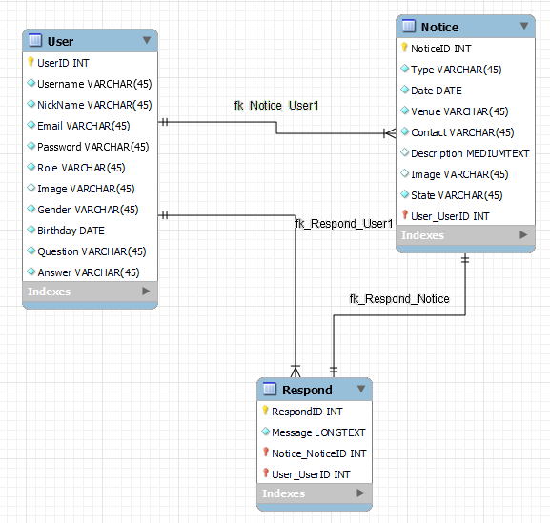

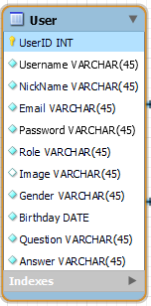

UserID <- Primary Key (Identify each user)

Username <- Login purpose

NickName <- Let user change

Password <- Login Purpose

Role <- Admin / User

Question and answer <- For reset password

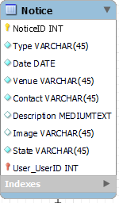

NoticeID <- Primary Key

Type <- Lost / Found

State <- Pending /Completed

User_UserID <- who create the notice (Foreign Key)

Without User, notice can’t exist (identifying relationship)

Relationship: one to Many ( one user can create many notice)

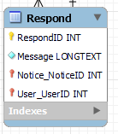

Respond ID <- Primary Key

Message <- The text

Notice_NoticeID <- the respond to which notice(Foreign Key)

User_UserID <- who respond(Foreign Key)

Without User and Notice, respond can’t exist (identifying relationship)

Relationship: one to Many ( one user can create many respond)

One to one (one respond to one notice)

All Function:

1. Home Page (Before Login)

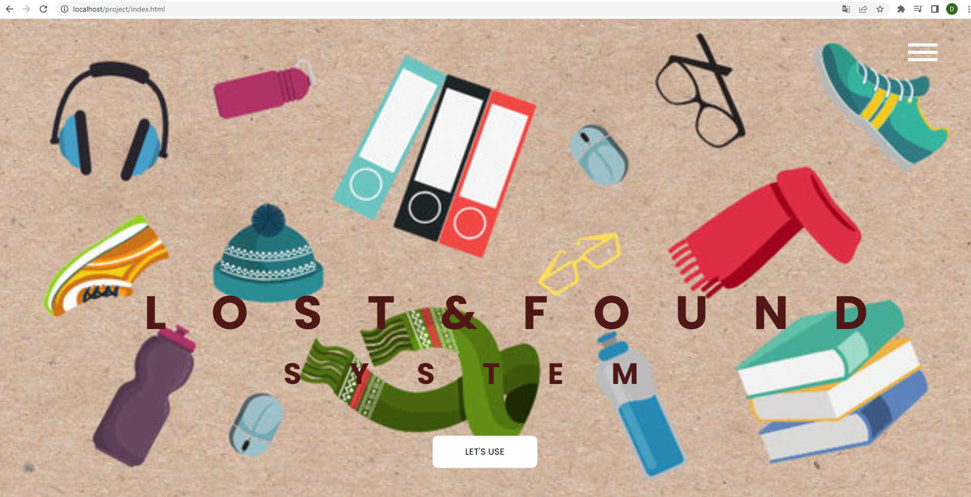

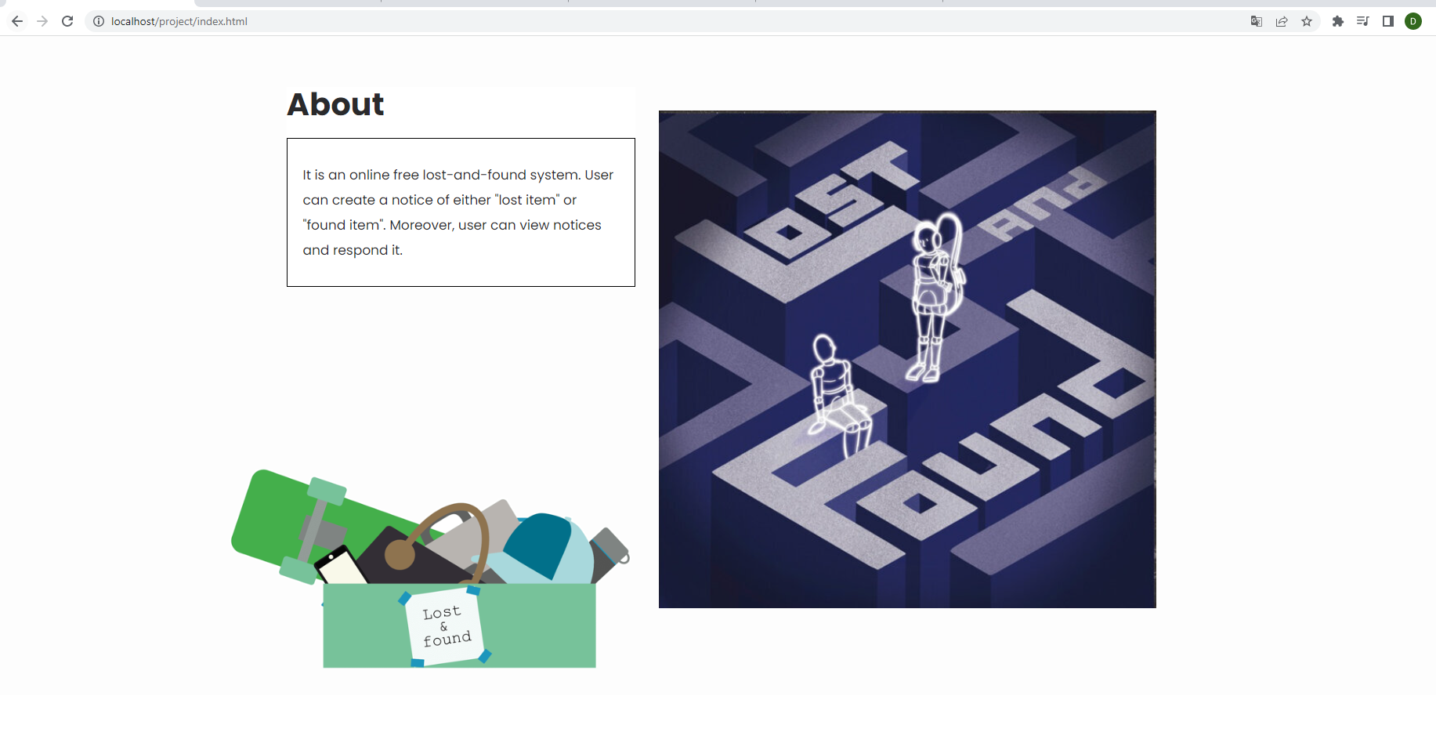

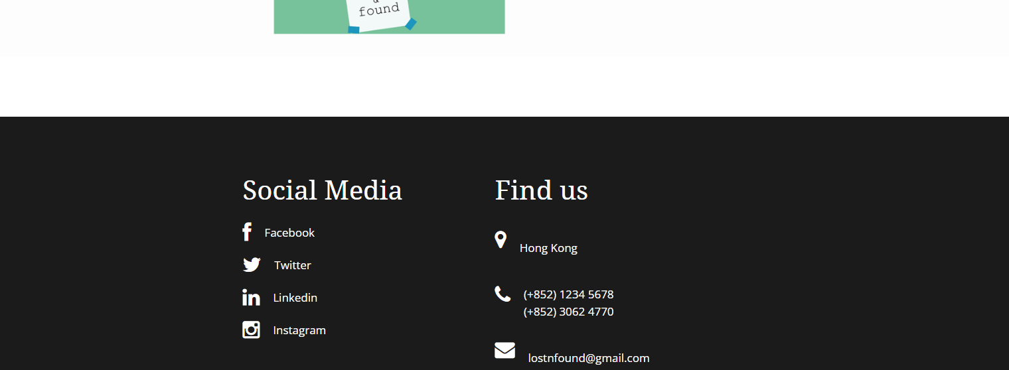

Click the button on the top right

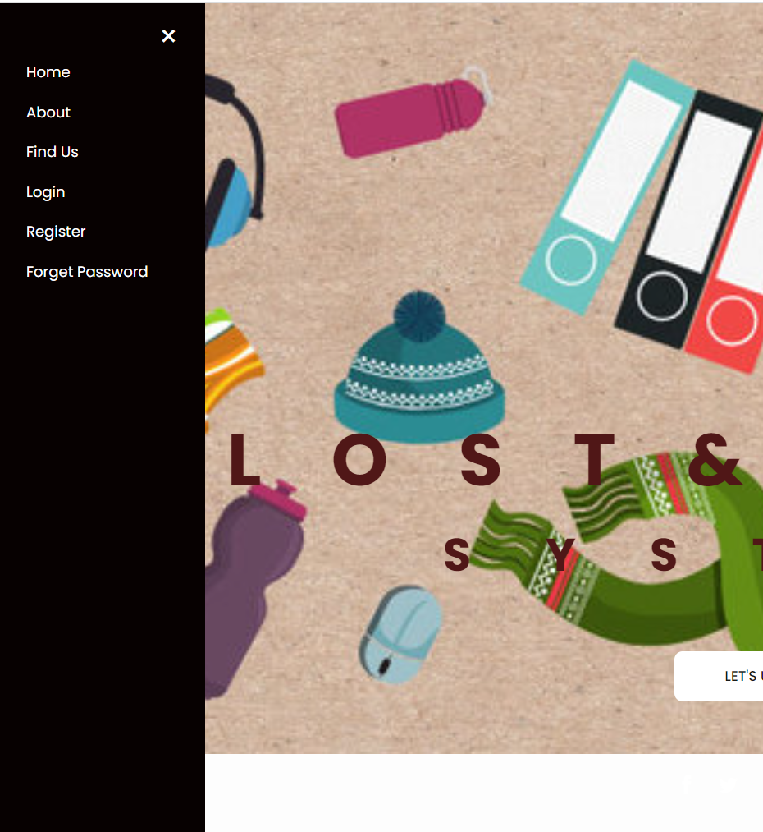

To open the panel ( Before Login )

Home <- Click it will direct people to home page or index.html

About <- Go to About Section in Homepage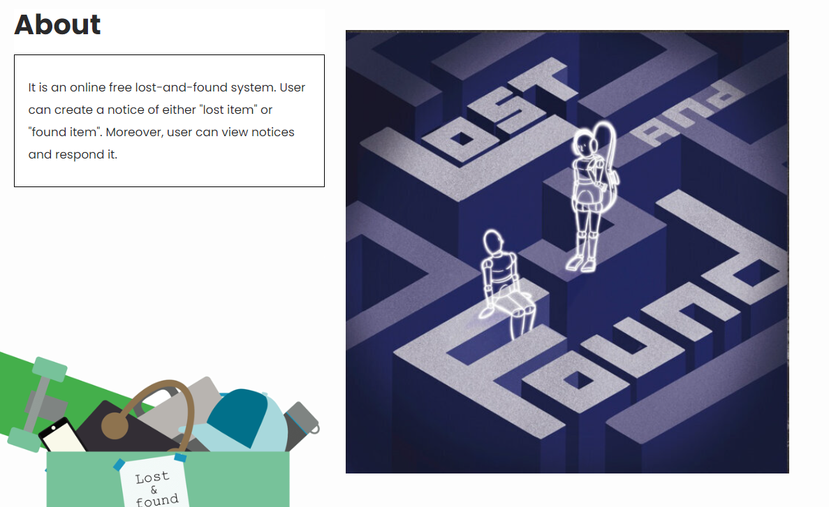

Find Us <- Go to Social Media and Find Us Section in Homepage

Login <- Go to Login Page

Register <- Registration Page

Forget Password <-reset password through answering the security question which set by user

1. Registration

There are two ways to go to registration page

Method 1(Click the let’s use button in Homepage):



Method 2(Click the Register in Black Panel):

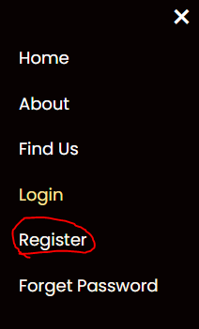

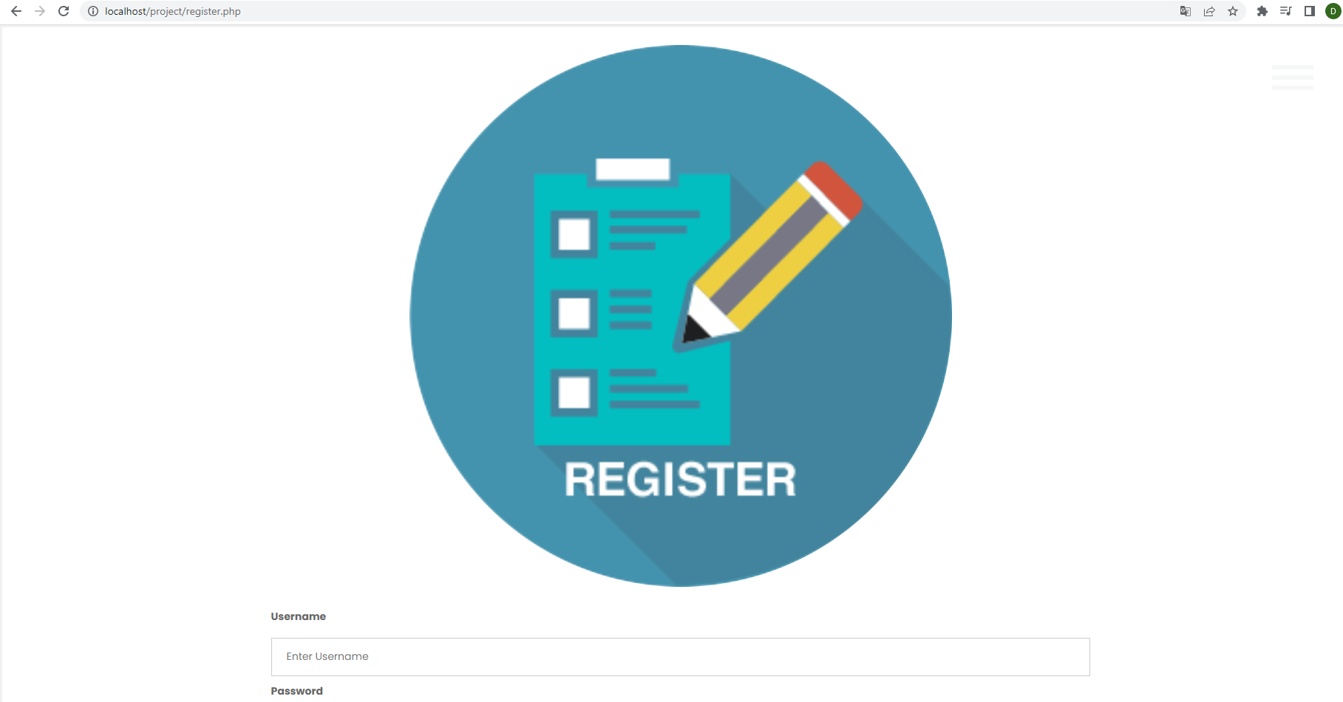

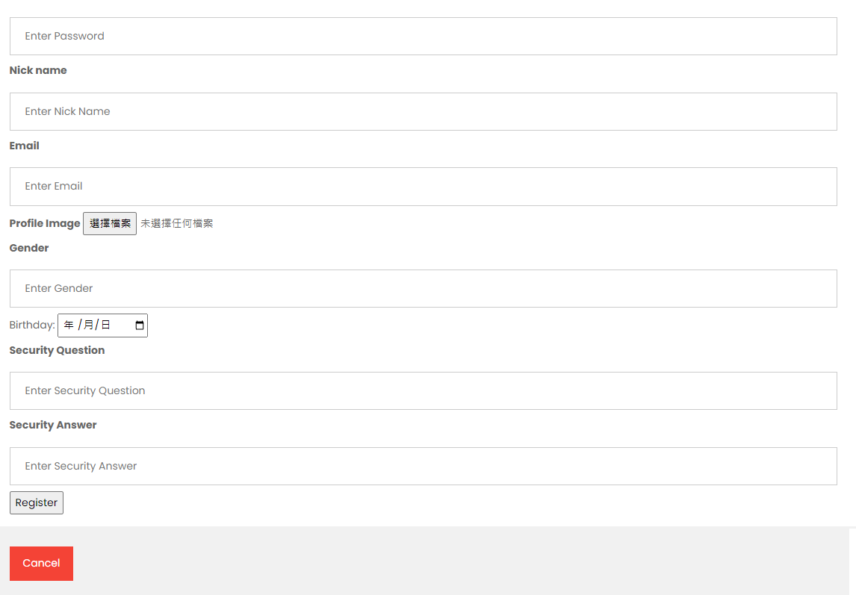

If User forget to enter some input,

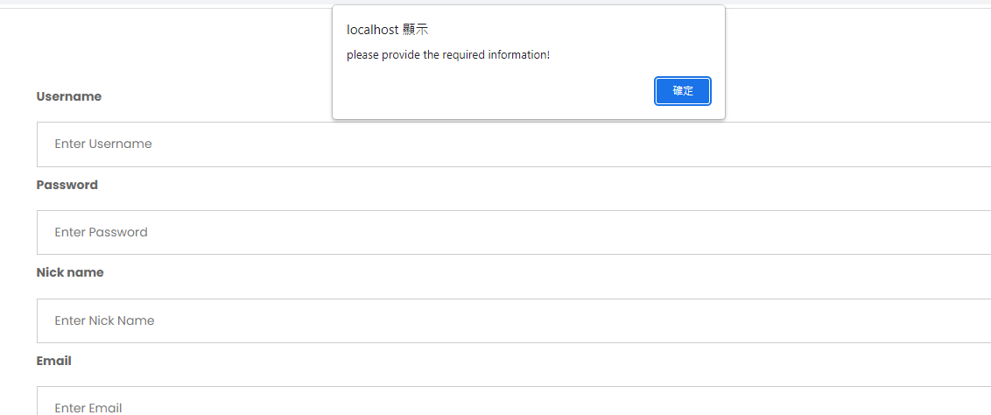

If User provide invalid email,

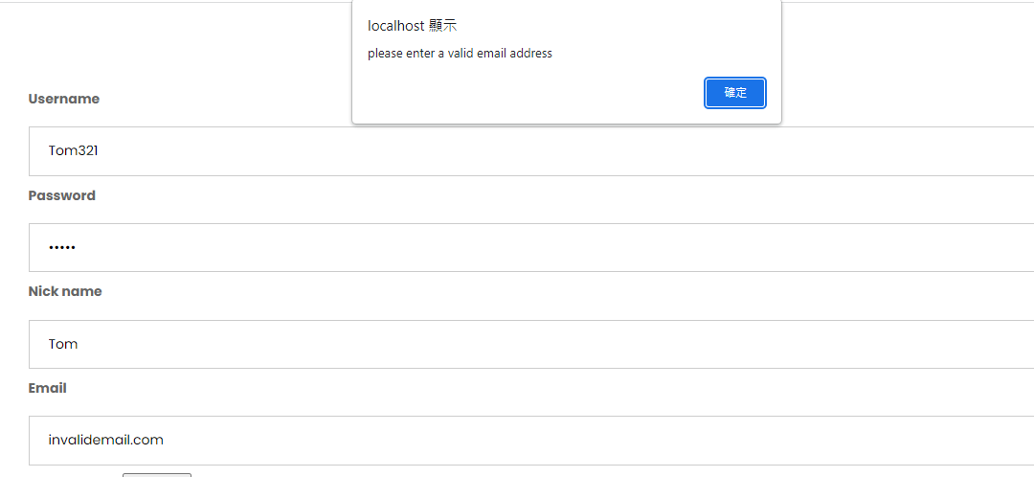

If success, the system will direct user to login page.

1. Forget Password/Reset Password

Method 1(Click the forgot password in Login):

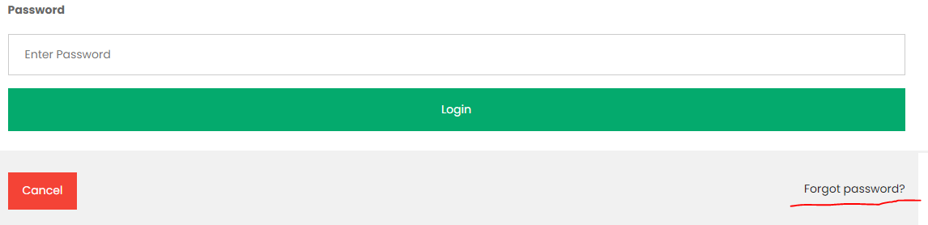

Method 2( Black Panel):

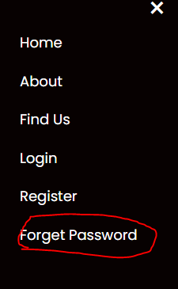

Forget Password Layout:

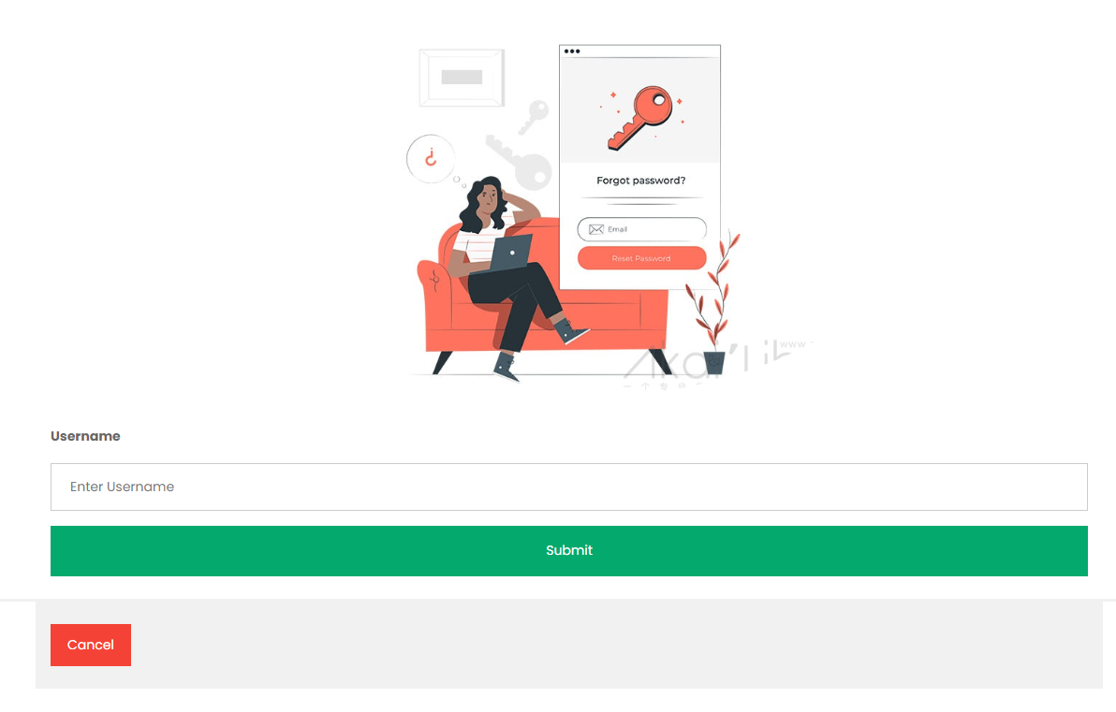

If username doesn’t exist,

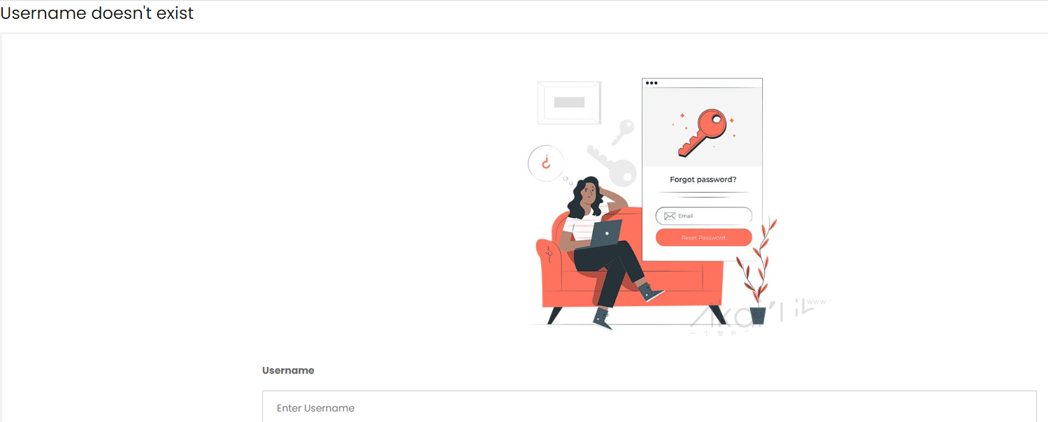

If username exist, User have to answer the security question

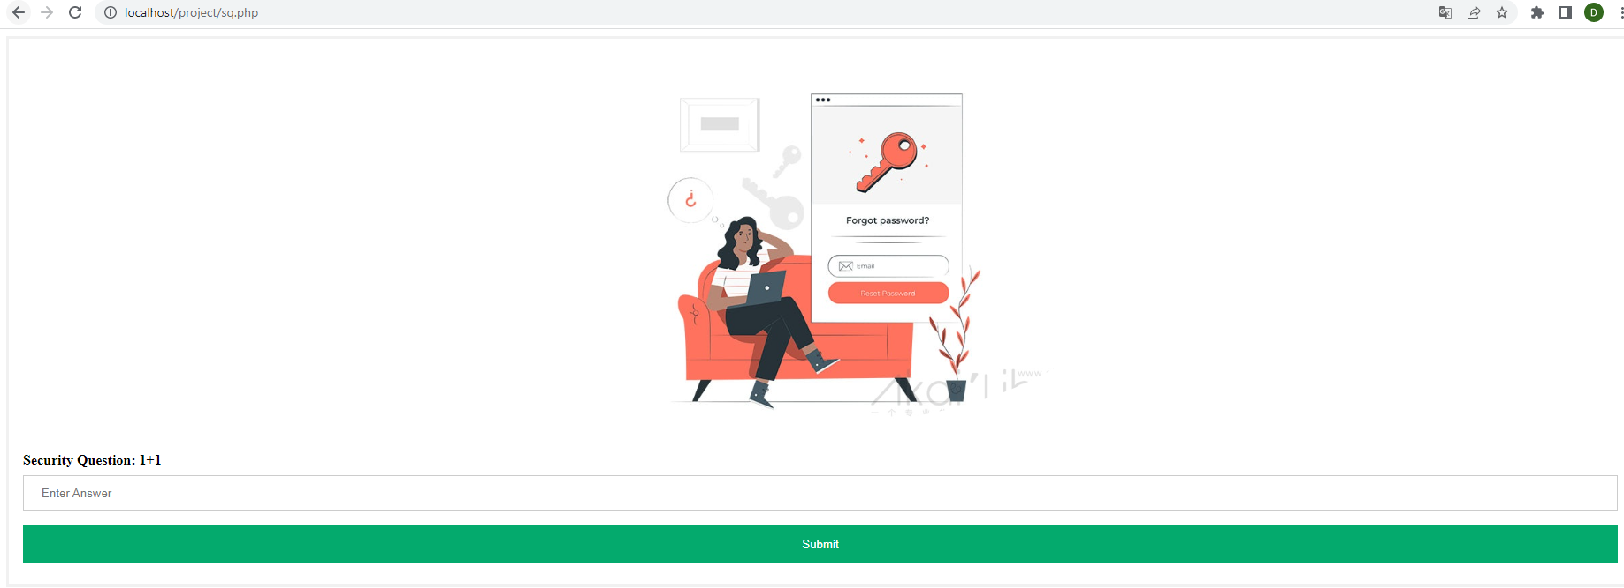

If user provide incorrect answer,

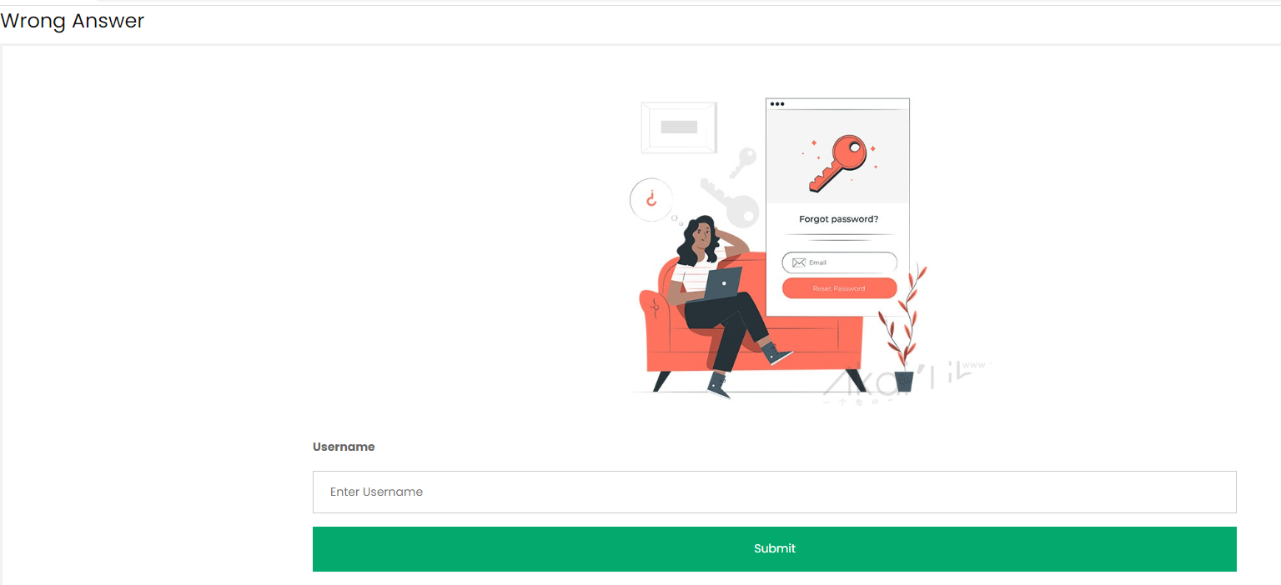

If user provide correct answer,

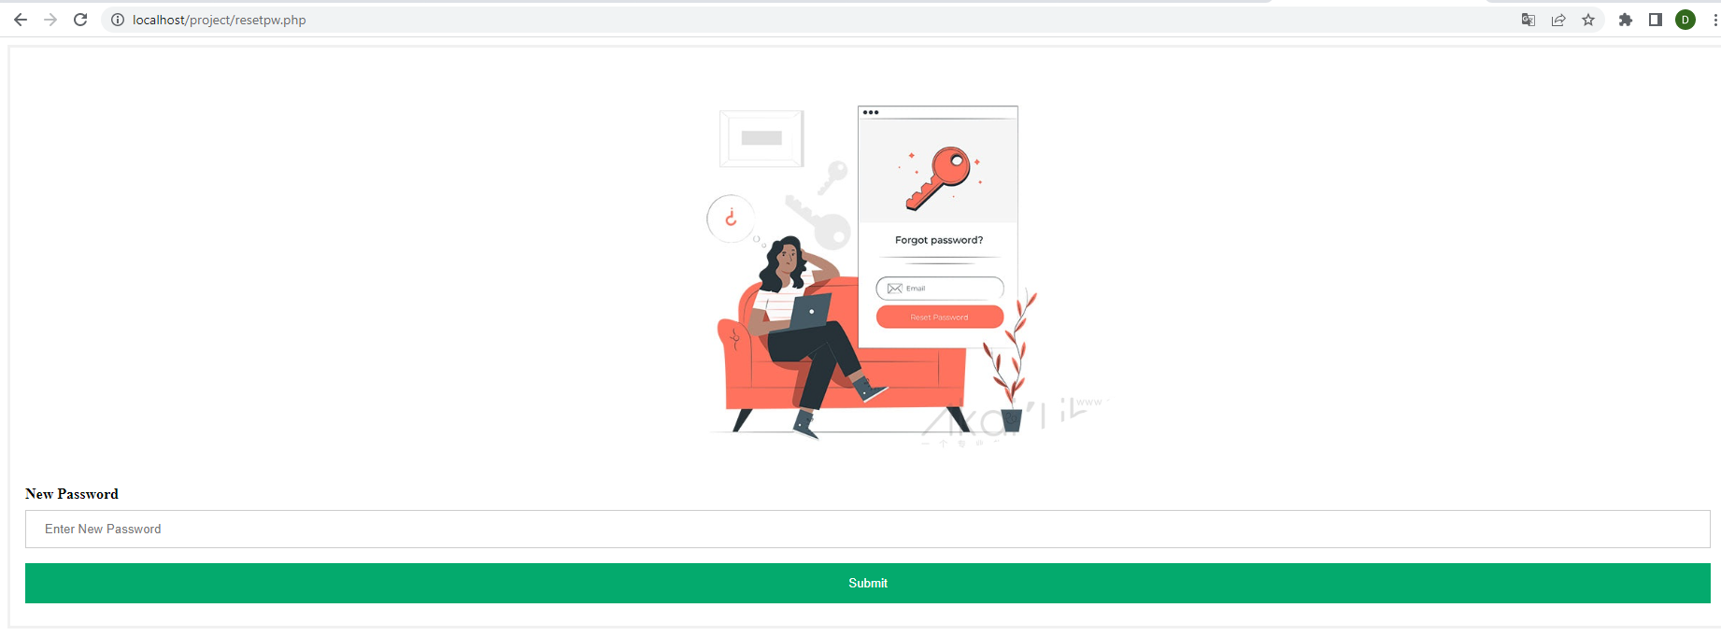

After entering new password, the system will direct user to login page.

1. Login

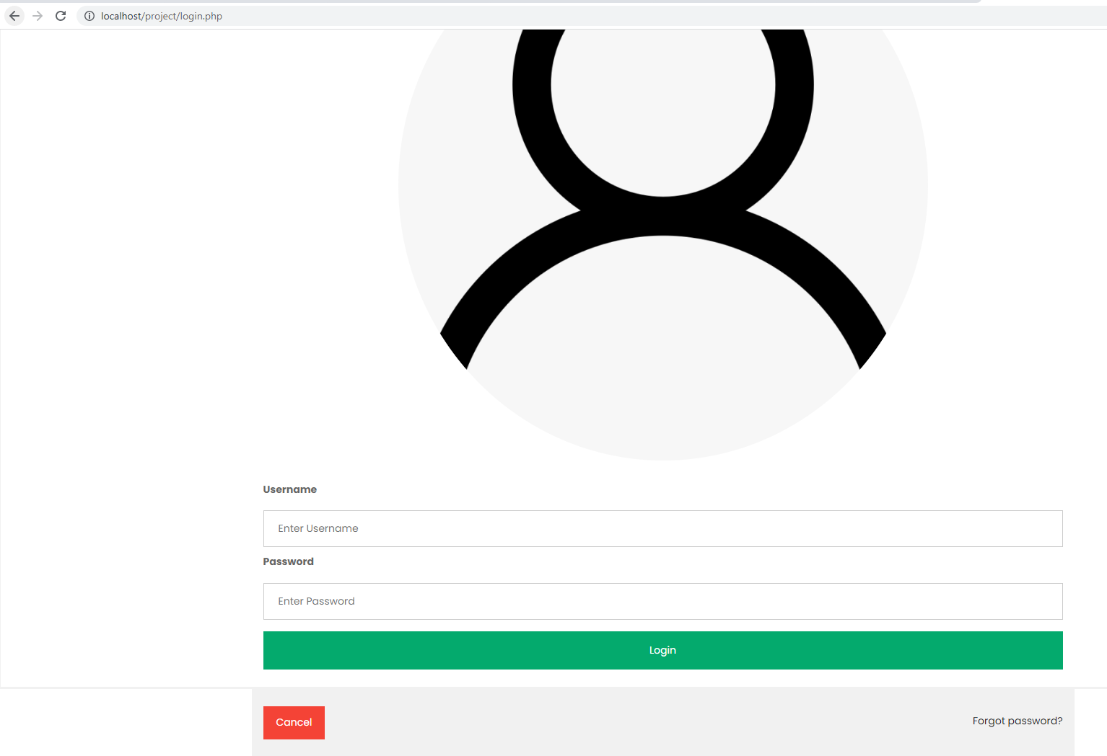

If the username or password is incorrect,

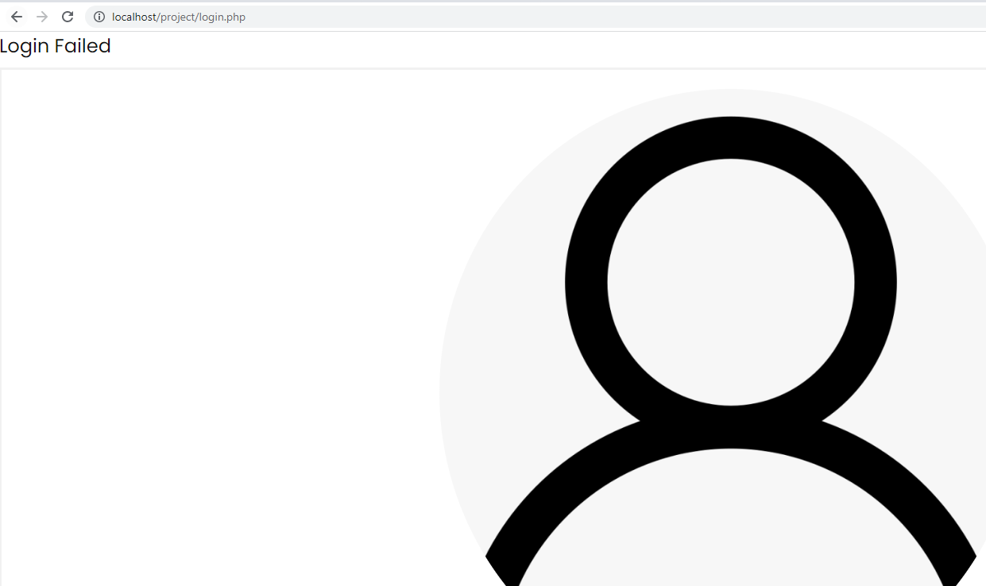

If login successfully, the system will direct user base on the account ‘role

Role : Admin -> direct to admin.php ( admin home page)

Role: User -> direct to user.php (user home page)

Moreover, the system will set cookie (username and password).

If user go to login page when the cookies are valid , the system will automatically direct user to their home page instead of login page.

1. User Home Page ( View Current Pending Notices in System)

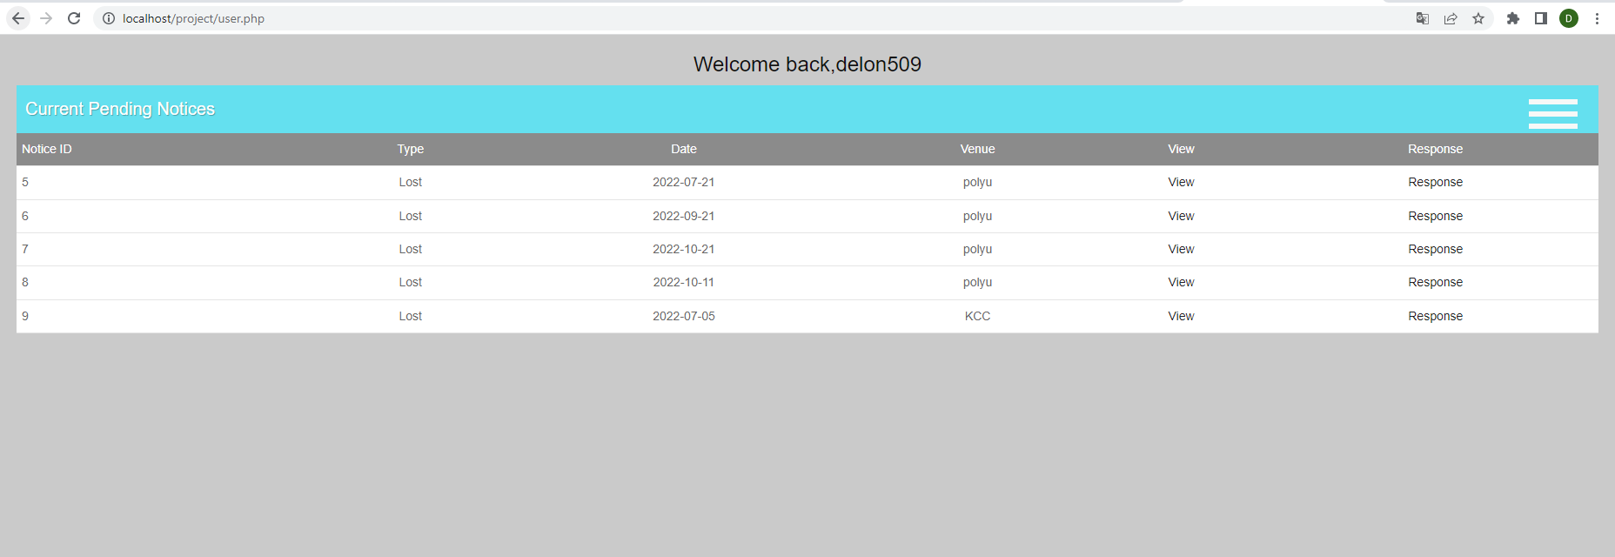

Black Panel ( For User):

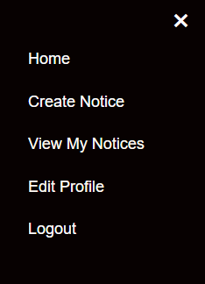

Home -> user.php (User homepage)

Create Notice -> Create Notice function

View My Notices -> View Notices created by user or responded by user

Edit Profile -> update user information

Logout -> Logout Function

If user click the view button in the table, he/she can view the notice’s detail

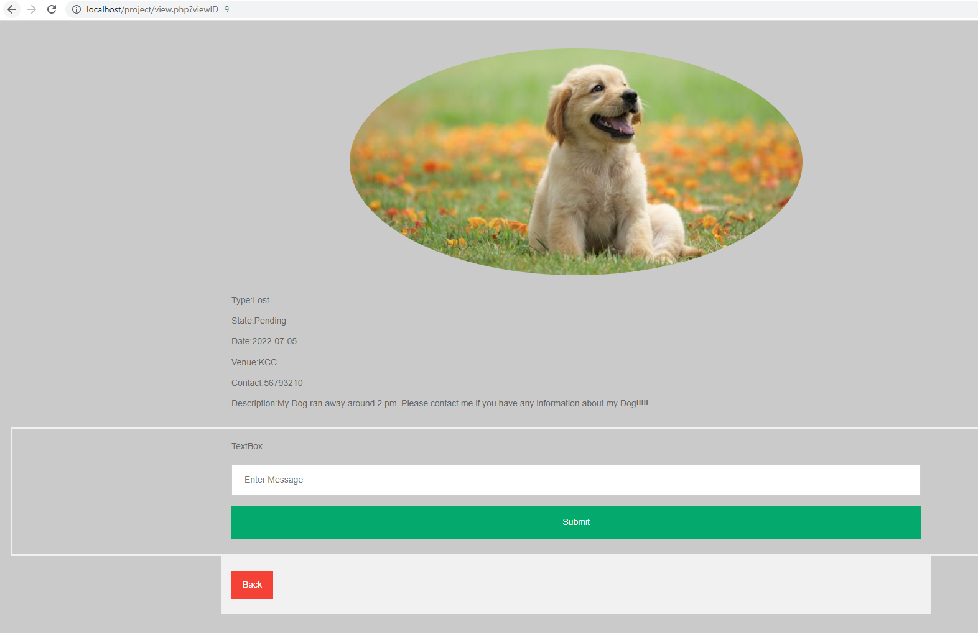

The user can respond by entering text in message field

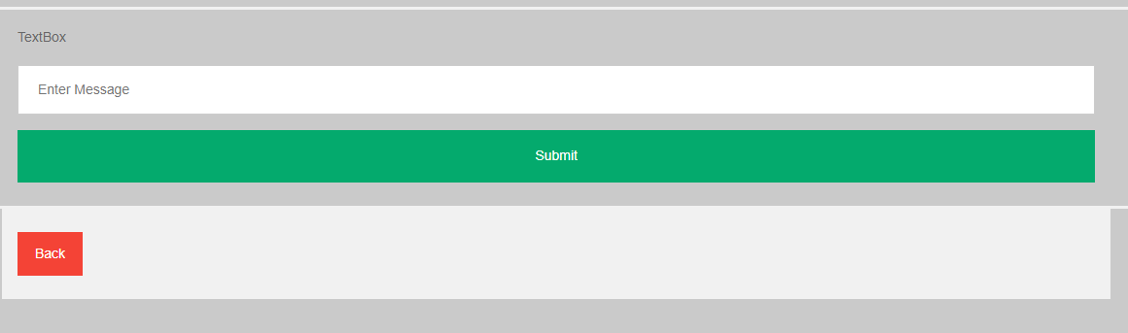

If user click submit button without entering text,

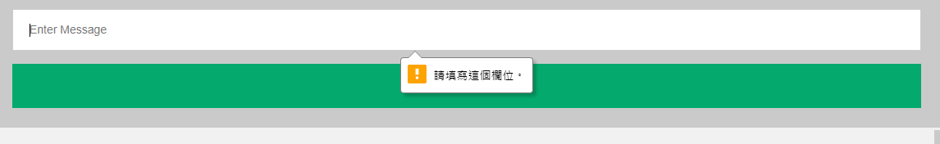

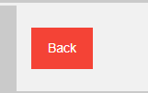

User can click back button to go back the home page.

If User click the response button in the table,

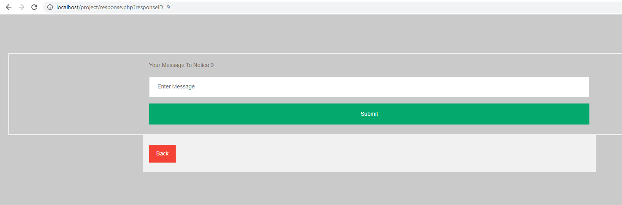

1. Create Notice

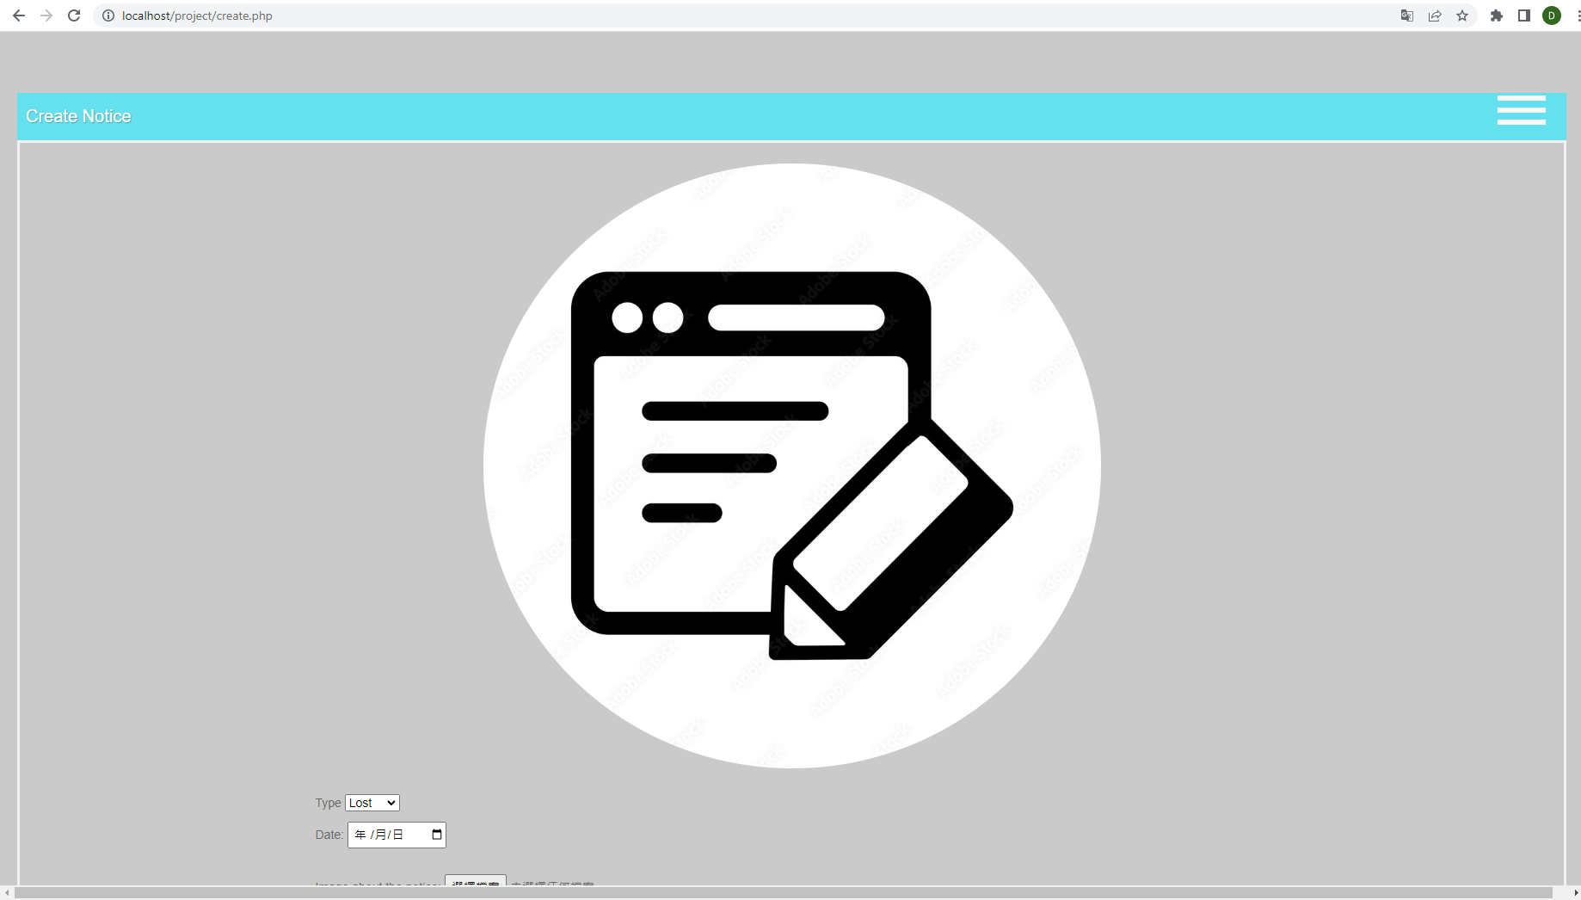

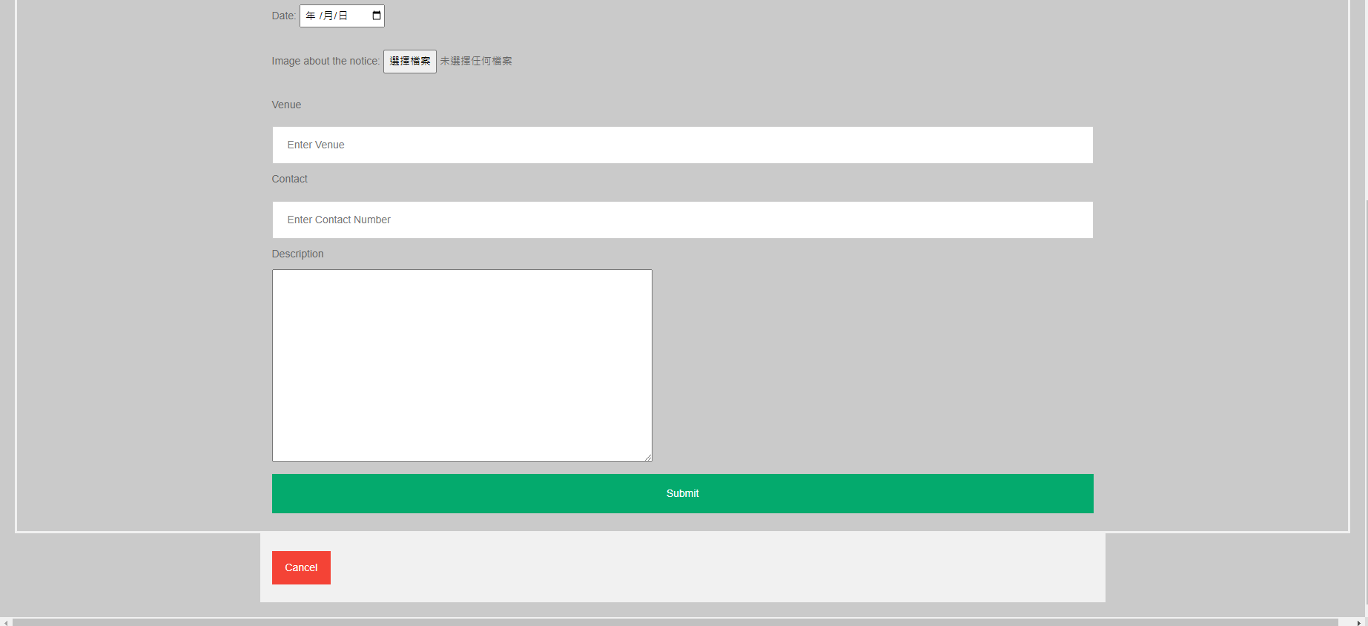

If User forget to enter some input,

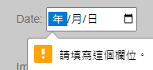

If user create successfully, the system will direct user to home page

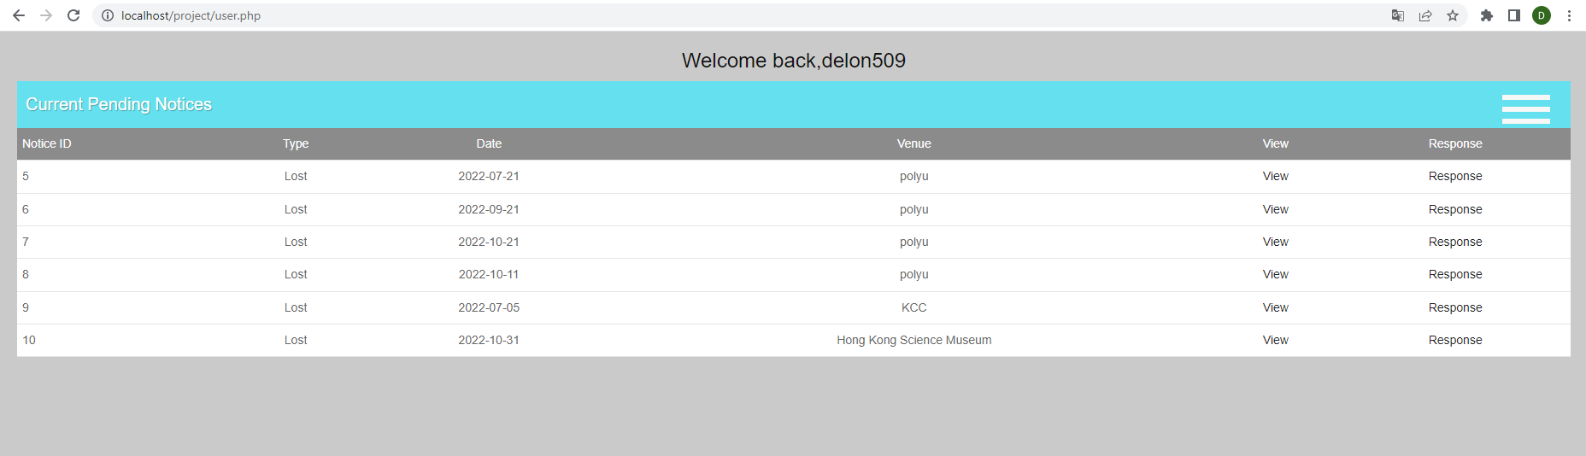

1. View My Notices

By default, the system shows the notices responded by the user.

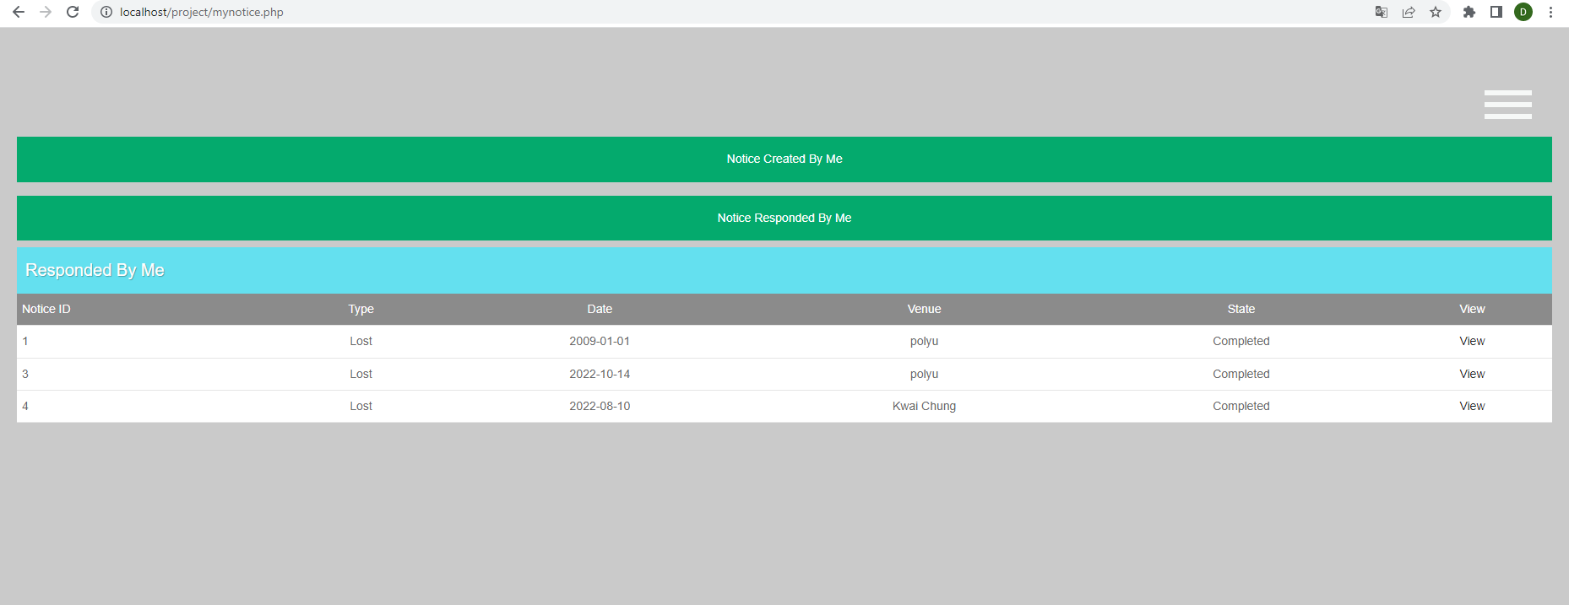

After clicking the view button in the table,

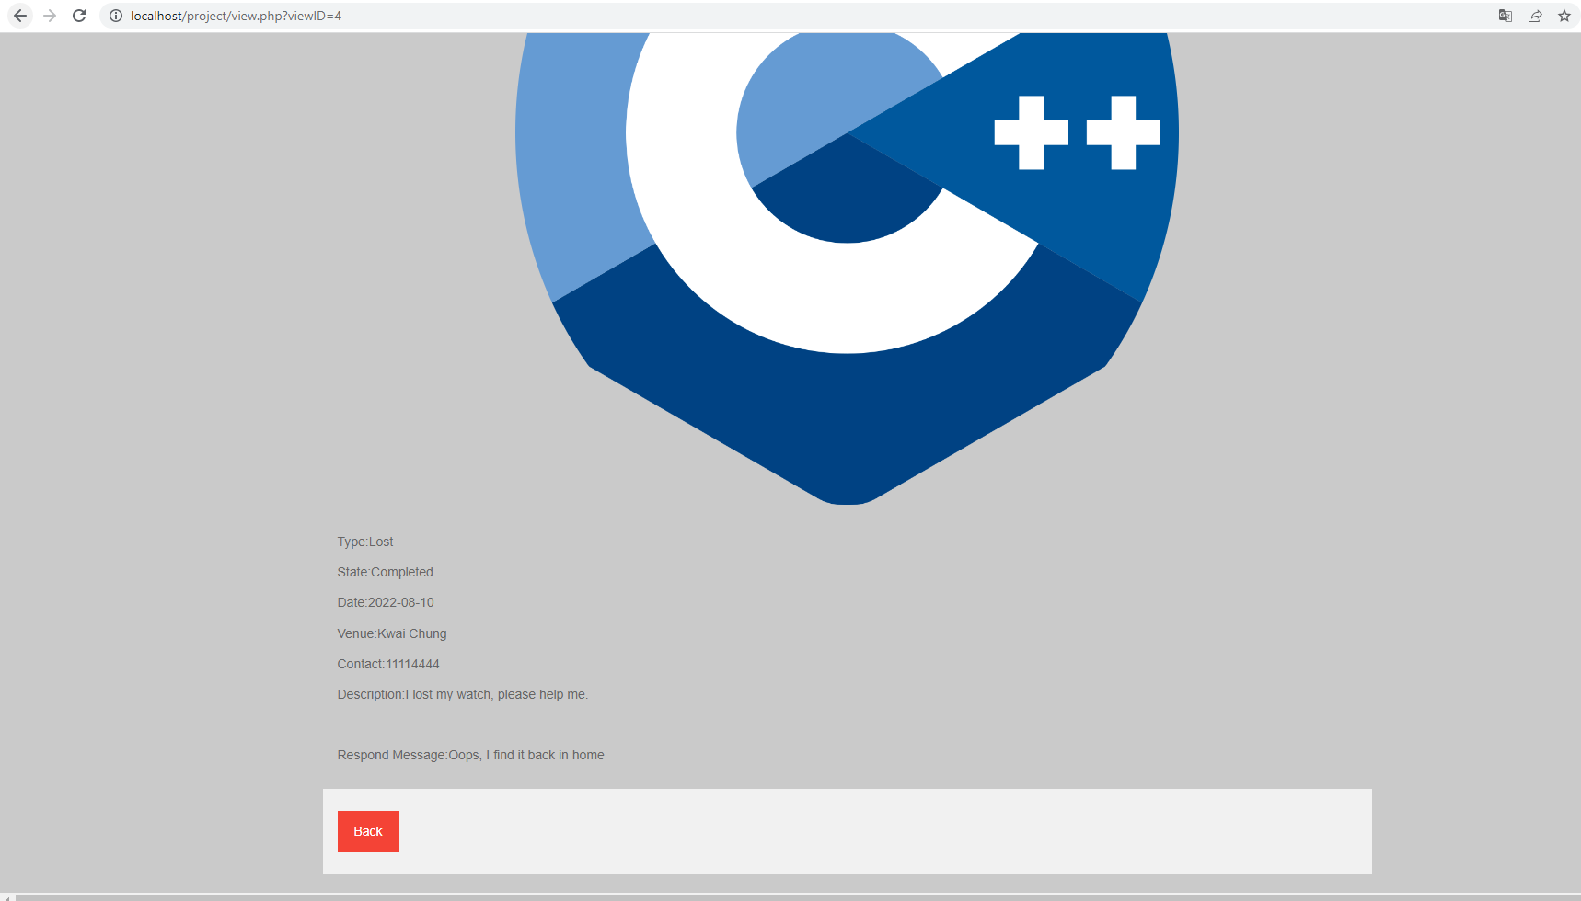

If user click the “Notice Created By Me” Button,

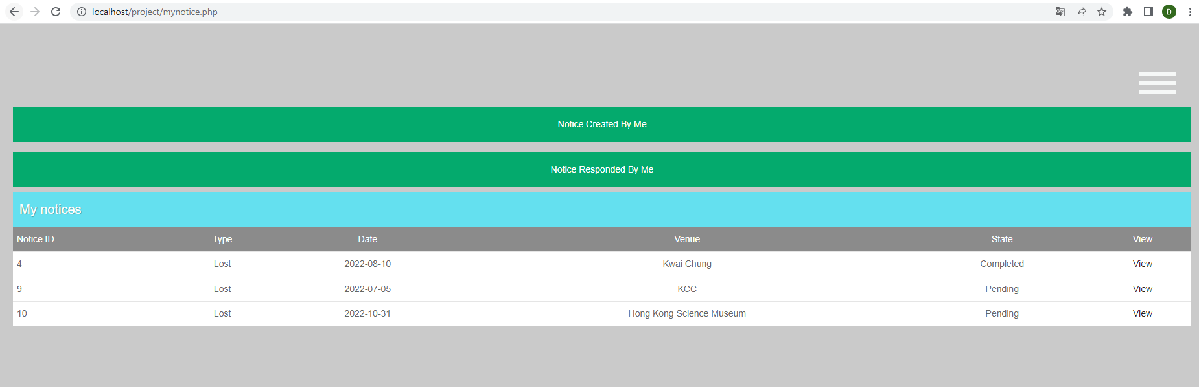

The System will show the notices created by user.

1. Edit Profile

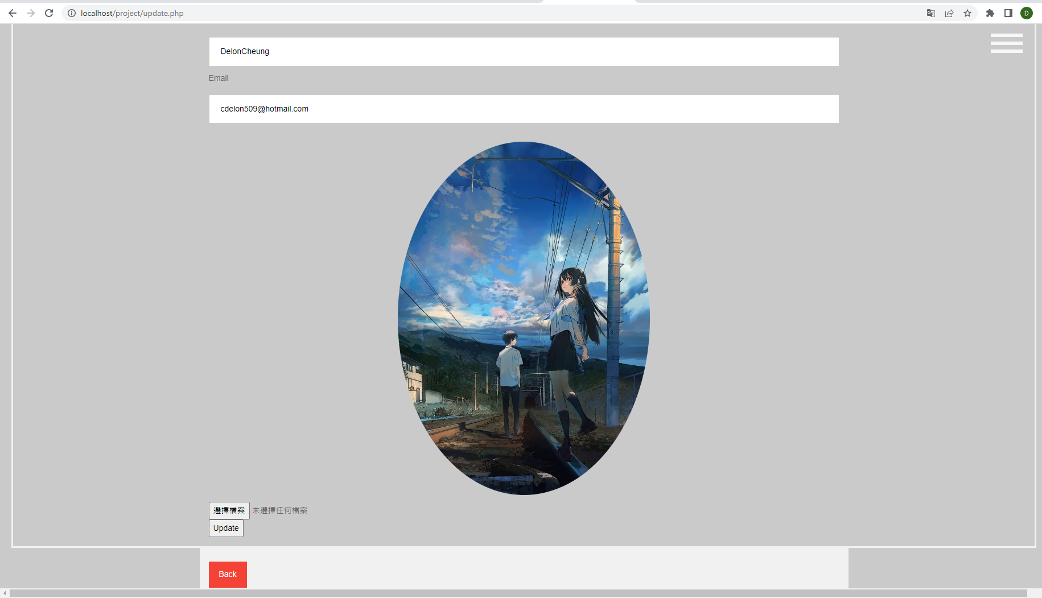

The text in each field is prefilled by the system according to the information in the database.

1. Logout

Delete the cookies and direct user to index.html / home page ( before login)



1. Admin Home Page (System Stat)

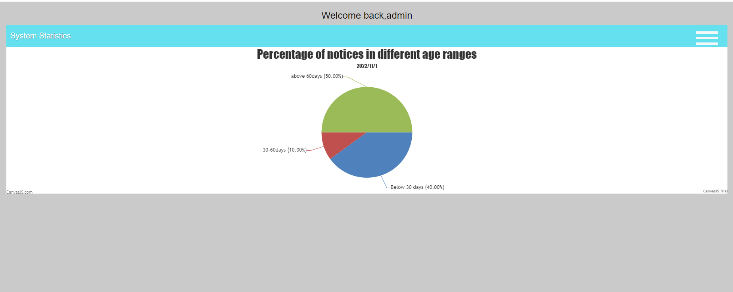

Black Panel ( For Admin):

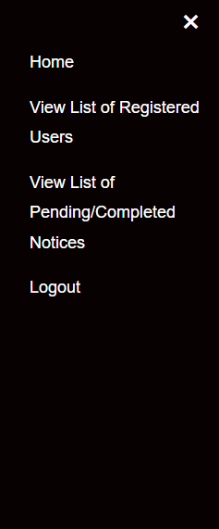

Home -> Admin Home page

View List of Registered Users -> User List

View List of Pending/Completed Notices -> Notices in System

Logout -> Same as logout function in user

1. View List of Registered Users

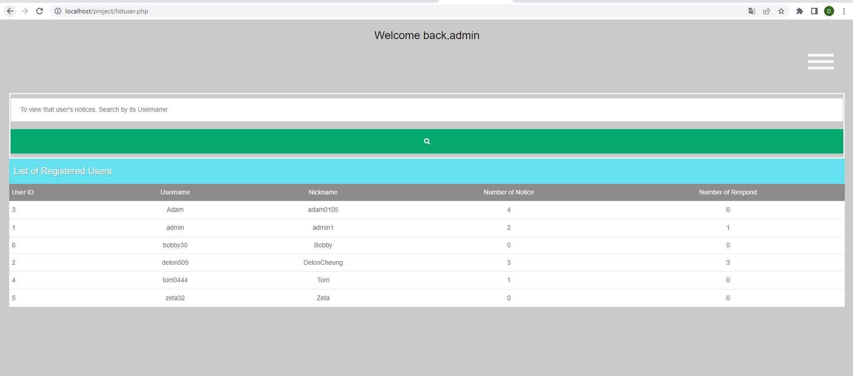

The Search bar is for viewing list of notices of A user

Example: If the admin search “delon509”,

By default, show the pending notice.

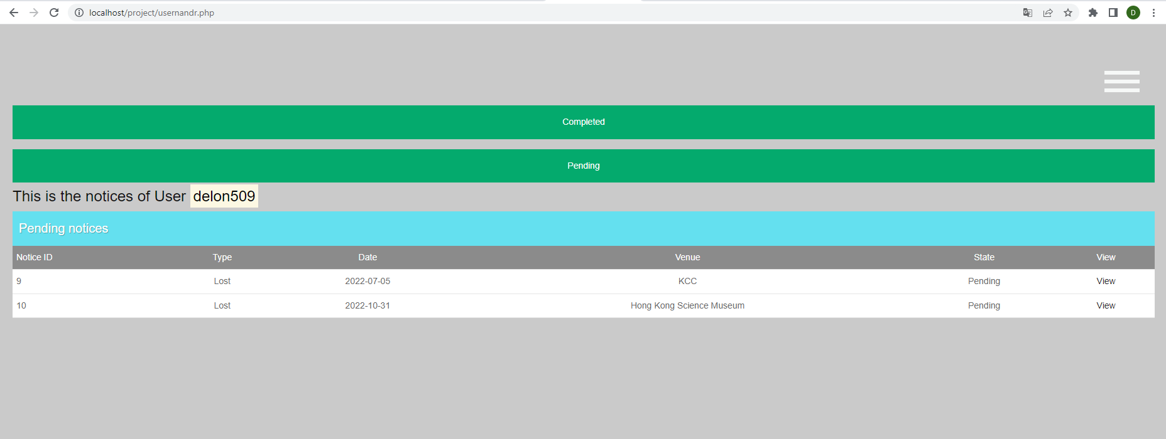

If the admin clicks the Completed button,

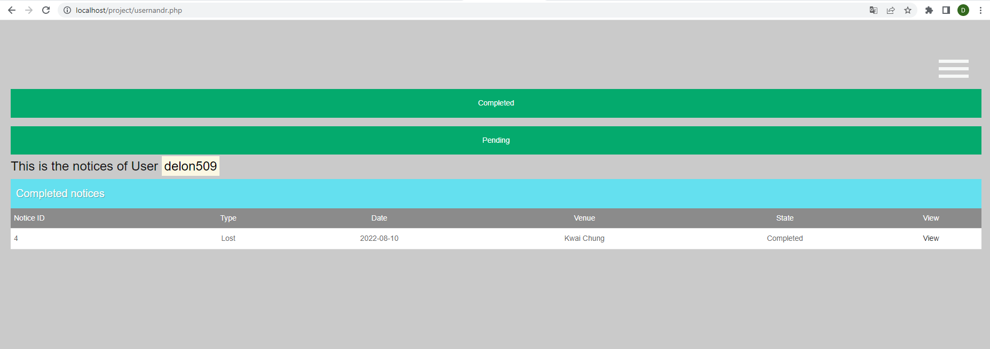

1. View List of Pending/Completed Notices

By default, the pending table is shown.

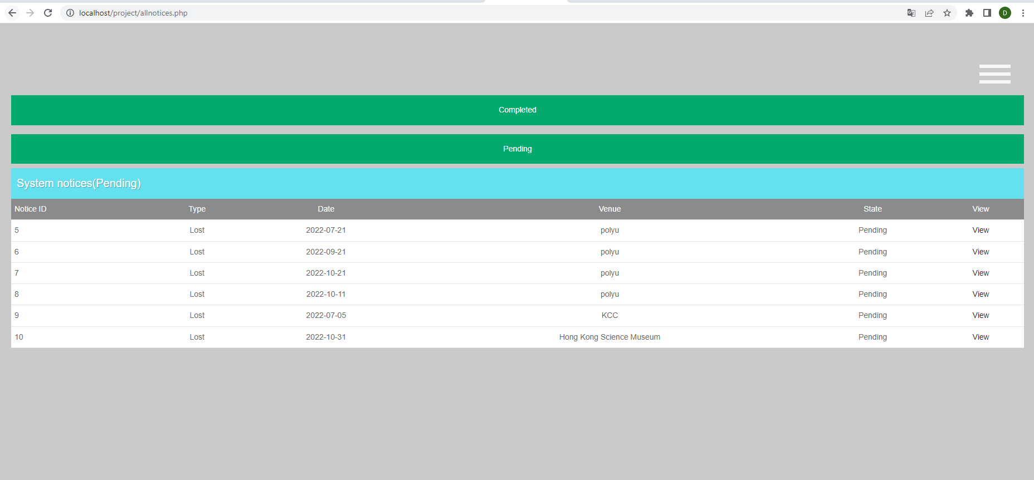

If the admin clicks the Completed button,

